Regional or Accented Diction

🌍 What is Regional / Accented Diction
# Source: AI Source: Provided by: [Data Path: Persons Table -> ID Column: 1, Name_En Column: Motasem Essam] -> From: [Chatgpt (GPT-4-turbo)] on [7/30/2025]
Regional or Accented Diction refers to the distinct pronunciation patterns, vocabulary, and expressions that are characteristic of a specific geographic area or native language background. It reflects the speaker's origin, cultural identity, or first language.

✅ Key Features:
# Source: AI Source: Provided by: [Data Path: Persons Table -> ID Column: 1, Name_En Column: Motasem Essam] -> From: [Chatgpt (GPT-4-turbo)] on [7/30/2025]
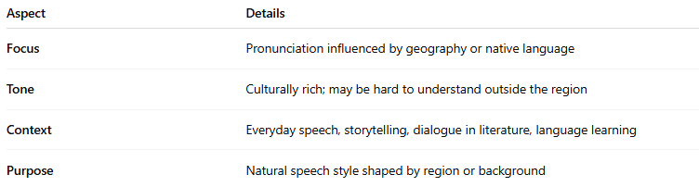
Aspect | Details
Focus | Pronunciation influenced by geography or native language
Tone | Culturally rich; may be hard to understand outside the region
Context | Everyday speech, storytelling, dialogue in literature, language learning
Purpose | Natural speech style shaped by region or background

🧠 Examples of Regional / Accented Diction:
# Source: AI Source: Provided by: [Data Path: Persons Table -> ID Column: 1, Name_En Column: Motasem Essam] -> From: [Chatgpt (GPT-4-turbo)] on [7/30/2025]
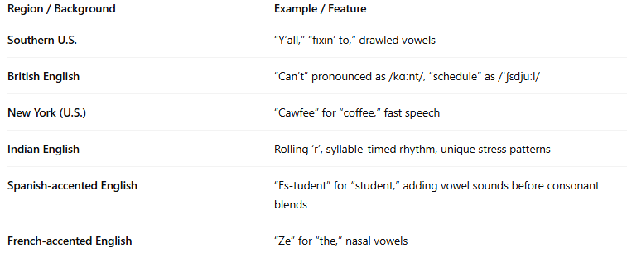
Region / Background | Example / Feature
Southern U.S. | “Y’all,” “fixin’ to,” drawled vowels
British English | “Can’t” pronounced as /kɑːnt/, “schedule” as /ˈʃɛdjuːl/
New York (U.S.) | “Cawfee” for “coffee,” fast speech
Indian English | Rolling ‘r’, syllable-timed rhythm, unique stress patterns
Spanish-accented English | “Es-tudent” for “student,” adding vowel sounds before consonant blends
French-accented English | “Ze” for “the,” nasal vowels

🗣️ Sample Sentences:
# Source: AI Source: Provided by: [Data Path: Persons Table -> ID Column: 1, Name_En Column: Motasem Essam] -> From: [Chatgpt (GPT-4-turbo)] on [7/30/2025]
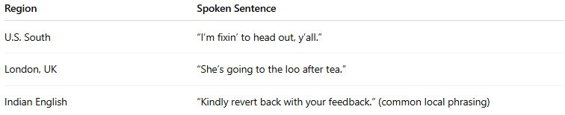
Region | Spoken Sentence
U.S. South | “I’m fixin’ to head out, y’all.”
London, UK | “She’s going to the loo after tea.”
Indian English | “Kindly revert back with your feedback.” (common local phrasing)

🆚 Regional Diction vs Clear Diction:
# Source: AI Source: Provided by: [Data Path: Persons Table -> ID Column: 1, Name_En Column: Motasem Essam] -> From: [Chatgpt (GPT-4-turbo)] on [7/30/2025]
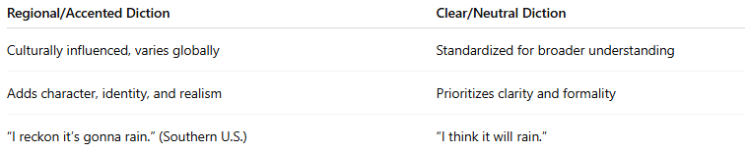
Regional/Accented Diction | Clear/Neutral Diction
Culturally influenced, varies globally | Standardized for broader understanding
Adds character, identity, and realism | Prioritizes clarity and formality
“I reckon it’s gonna rain.” (Southern U.S.) | “I think it will rain.”

🧭 Used In:
# Source: AI Source: Provided by: [Data Path: Persons Table -> ID Column: 1, Name_En Column: Motasem Essam] -> From: [Chatgpt (GPT-4-turbo)] on [7/30/2025]
- Dialect studies
- Character dialogue in fiction
- Language learning and ESL
- Linguistic analysis
- Speech recognition software training

💡 Note:
# Source: AI Source: Provided by: [Data Path: Persons Table -> ID Column: 1, Name_En Column: Motasem Essam] -> From: [Chatgpt (GPT-4-turbo)] on [7/30/2025]
Regional diction isn’t “wrong”—it adds richness and diversity to language. However, in global communication, some may adopt neutral pronunciation to ensure understanding across accents.

